Total rides:

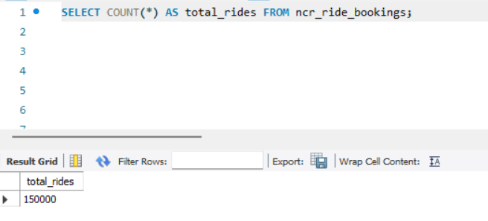
Completed vs Cancelled vs Incomplete:
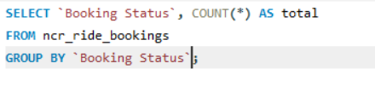
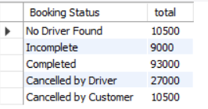
Customer vs Driver cancellations:
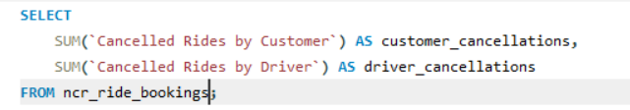

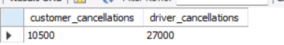

2. Revenue Analysis
Total revenue:
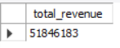
Revenue by payment method
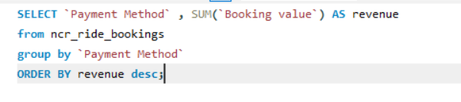
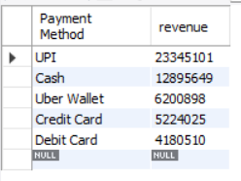

Revenue by vehicle type:
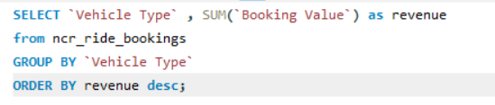
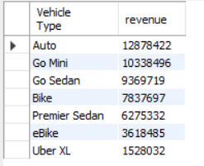
3. Ride Patterns:
Top 5 pickup locations:-
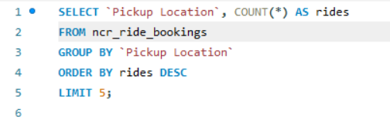
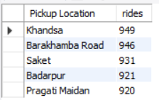

Top 5 drop locations:
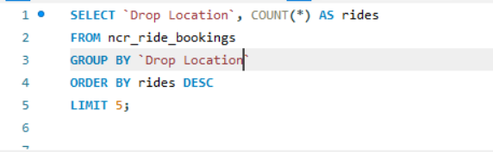
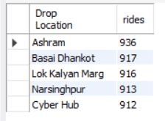
Average ride distance per vehicle type:
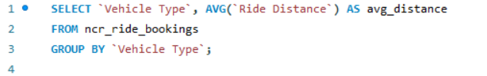
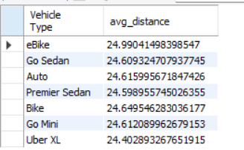

4. Cancellations:
Reasons for customer cancellations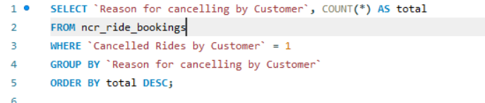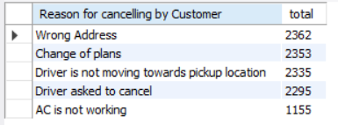
Reasons for driver cancellations
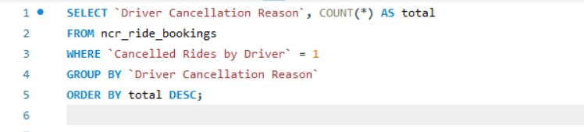
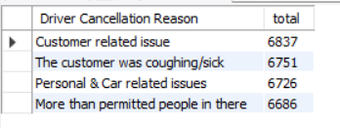

5. Ratings:
Average driver rating by vehicle type: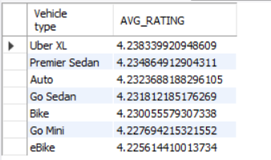
Average customer rating by vehicle type:
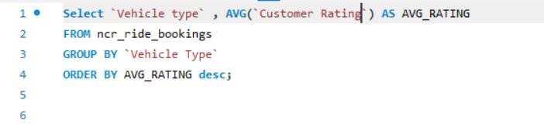
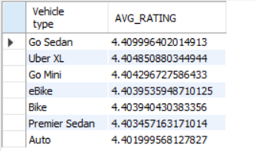

6. Time Trends:
Monthly rides:
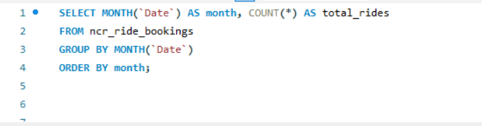
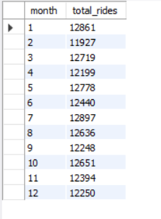
Monthly revenue:
